Bimetal thermometer also qualified for -70 °C
Klingenberg, July 2016.
WIKA has extended the range of its model 55 bimetal thermometer - this proven measuring instrument is now available in a version that can withstand ambient temperatures down to -70 °C.

Following the PG23LT pressure gauge, WIKA now also has a mechanical temperature measuring instrument available for operation in extreme cold - all components of the elastomer-free case made of stainless steel and its filling to prevent condensation are specified accordingly. Other environmental influences are prevented through IP65 and IP66 ingress protection (in accordance with EN 60529 / lEC 60529).

Applications for the new version of the model 55, which measures in scale ranges of -70 °C … +250 °C, are mainly for the oil, gas and petrochemical industries. Bimetal thermometers are generally suited for use under extreme climatic conditions since the ambient temperature has no effect on the measured value. For applications in the Eurasian markets, mainly in Russia, the model 55 is available with EAC approval.

Number of characters: 1006
Key word: Bimetal thermometer model 55 for extreme cold

Manufacturer:
WIKA Alexander Wiegand SE & Co. KG
Alexander-Wiegand-Straße 30
63911 Klingenberg/Germany
Tel. +49 9372 132-0
Fax +49 9372 132-406
vertrieb@wika.com
www.wika.de

WIKA company photograph:
WIKA model 55 can be used, if required, in extreme cold to -70 °C

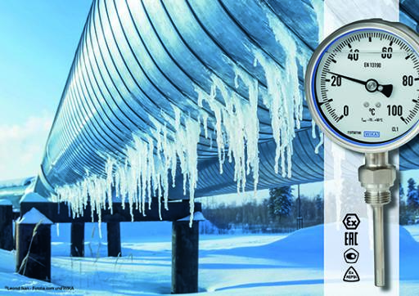

Edited by:
WIKA Alexander Wiegand SE & Co. KG
André Habel Nunes
Marketing Services
Alexander-Wiegand-Straße 30
63911 Klingenberg/Germany
Tel. +49 9372 132-8010
Fax +49 9372 132-8008010
andre.habel-nunes@wika.com
www.wika.de

WIKA press release 11/2016

